2017-2018 CONSOLIDATED ANNUAL ACTION PLAN SUBMISSION

SUPPORTING APPENDICES

Pawtucket Citizens Participation Guide
Citizen Participation/Consultation Efforts
2015-2020 Strategic Plan Priorities

CITY OF PAWTUCKET, RHODE ISLAND

CITIZENS PARTICIPATION GUIDE

for

COMMUNITY DEVELOPMENT BLOCK GRANT (CDBG) PROGRAM

HOME HOUSING INVESTMENT PARTNERSHIP (HOME) PROGRAM

EMERGENCY SOLUTIONS GRANT (ESG) PROGRAM

JANUARY, 2017

Sponsored by:
Pawtucket Department of Planning and Redevelopment
137 Roosevelt Avenue, First Floor
Pawtucket, RI 02860
Telephone: 401-728-0500
TDD Machine: 401-722-8239

This seven-part guide is being published to assist the citizens of Pawtucket, Rhode Island with their understanding of the City’s three (3) major federal housing and community development programs:

- The Community Development Block Grant (CDBG);
- The HOME Housing Investment Partnership (HOME);
- The Emergency Solutions Grant (ESG).

Grouped together under one overall cohesive strategy designed to meet Pawtucket’s housing and community development needs, these programs provide the basis for the City’s Consolidated Plan Submission to the Department of Housing and Urban Development.

The guide is divided into seven (7) sections:

- Explanation of Programs;
- Participation Efforts Directed to Residents;
- Assistance for Handicapped, Disabled, Non-English Speaking Individuals;
- Availability of Assistance in Preparing Funding Proposals;
- Access to Information;
- Displacement/Relocation Assistance;
- Citizen Comment, Response to Written Complaints, Program Amendments.

Attachment A - Low and Moderate Income Scale by Family Size
Attachment B – 2017-2018 Consolidated Plan Activity Schedule
Attachment C - City - Organizations
Attachment D - Displacement and Relocation Policy
Attachment E - 2015-2020 Consolidated Plan Strategic Priority Area Summary

**Questions and comments about this guide should be directed to the:

City of Pawtucket, Rhode Island
c/o Department of Planning and Redevelopment
137 Roosevelt Avenue, First Floor
Pawtucket, RI 02860
Attention: Edward G. Soares, CD Program Manager

Telephone: 401-728-0500 Ext. 441
E-Mail: esoares@pawtucketri.com

PROGRAM EXPLANATION

The City of Pawtucket, Rhode Island receives federal funding for the operation of three separate programs: the Community Development Block Grant, the HOME Housing Investment Partnership Program, and the Emergency Shelter Grant. Each of the programs (described below) are designed to assist Pawtucket residents, primarily those residents who have low and moderate incomes (see Attachment A).

Community Development Block Grant (CDBG): The CDBG Program is used to assist Pawtucket residents in a number of ways including: providing low cost loans to fix-up single and multi-family homes, installing new streets and sidewalks, making loans to local businesses, funding for neighborhood and senior centers, assisting families with child care, and many other activities directed at improving the lives of Pawtucket residents.
HOME Housing Investment Partnership (HOME): The HOME Program is used to assist Pawtucket residents with their housing. Programs funded with HOME dollars include: the non-profit development of affordable housing, a first-time homebuyers’ program, and rental assistance to tenants.
Emergency Solutions Grant (ESG): The ESG Program is used to help provide emergency shelter assistance to organizations assisting the homeless.

The Consolidated Plan: Each year the U. S. Department of Housing and Urban Development requires communities receiving the above funds to submit a comprehensive, coordinated strategy outlining how it will use these funds to meet the needs of the community. This strategy plan is known as the Consolidated Plan.
For more information about these programs, please contact the Department of Planning and Redevelopment at the address and phone shown on the front of this guide.

II. PARTICIPATION EFFORTS DIRECTED TO RESIDENTS

The City of Pawtucket encourages the participation of all its residents in deciding how best to utilize the funding from the CDBG, HOME, and ESG Programs. The following methods are employed to involve Pawtucket residents in the decision-making process:

- News Releases to Community Groups: The City of Pawtucket maintains a large mailing list of community groups throughout the City. The City has used and will continue to use this list to inform Pawtucket residents of meetings, informational reports, application availability, and the willingness of the City to provide technical assistance in filling out CDBG, HOME, and ESG applications. < If you are a community group and would like to be placed on the mailing list, please contact the Pawtucket Department of Planning and Redevelopment at the address, phone or e-mail web-site shown on the front of this guide.>

2. Public Meetings: The City of Pawtucket routinely holds public meetings concerning information related to the CDBG, HOME and ESG programs. All such meetings are advertised and announced in the sources noted below.
3. Availability of Reports/Information: The City of Pawtucket routinely produces information relating to the performance of particular programs, called performance reports. The availability of these reports is advertised in the sources noted below. The Pawtucket Department of Planning and Redevelopment maintains reports for the five previous program years.
4. Newspaper Advertising/Press Releases: The City of Pawtucket places advertisements in The Times, to inform citizens of Pawtucket of public meetings and information relating to CDBG, HOME and ESG. These advertisements are placed at least two (2) weeks in advance of any deadline and contain information on how to contact the City with any questions.
The City also issues press releases to a variety of community newspapers concerning matters relating to CDBG, HOME, and ESG. Newspapers which receive press releases include: The Times, Americanewsne Espanol Newspaper, and the Providence Journal.
5. Efforts to involve residents of low, very low and extremely low income: The City of Pawtucket specifically targets those organizations serving residents with lower incomes for assistance in reaching these people.

6. Efforts to reach minority populations: The City of Pawtucket uses both direct mail to key organizations and minority newspaper advertising to help reach minority populations residing in the City of Pawtucket.

III. ASSISTANCE TO HANDICAPPED, DISABLED, AND NON-ENGLISH

SPEAKING INDIVIDUALS

The City of Pawtucket will provide whatever assistance is necessary to insure its citizens have access to meetings and information relating to its CDBG, HOME, and ESG programs. Should you have a problem not addressed in this guide, please contact the Pawtucket Department of Planning and Redevelopment for special assistance.

- Assistance to physically handicapped: The City of Pawtucket is working toward making all of its facilities accessible to the disabled. At present, the principal facilities which involve matters relating to CDBG, HOME, and ESG are accessible as follows:
- Department of Planning and Redevelopment, 137 Roosevelt Avenue, First Floor, – All information and technical assistance relating to CDBG, HOME, and ESG;
- Blackstone Valley Visitors Center Theatre, 175 Main Street;
- City Hall, 137 Roosevelt Avenue – Mayor’s Office and City Council Chambers;
- Pawtucket Public Library, 13 Summer Street and;
All newspaper advertisements mention that these facilities are accessible to the physically disabled.

- Assistance for individuals with disabilities: The City of Pawtucket will take whatever steps necessary to accommodate the needs of individuals with disabilities, including hiring a sign language interpreter if needed for a public meeting. All newspaper advertisements request that individuals with special needs contact the Pawtucket Department of Planning and Redevelopment for arranging special assistance.

- Assistance for non-English speaking individuals: The City of Pawtucket recognizes that not all Pawtucket residents speak and understand English as their first language. To help overcome this language barrier, the City of Pawtucket offers the following:

- Advertising: Major public meeting/information notices are carried in the local Spanish language newspaper, Americanewsne Espanol.

- Translators: The City of Pawtucket can employ interpreters to help translate English at public meetings. Public notices remind residents to call in advance of the meeting if they require translation services for any language.

- Literature: The City of Pawtucket can have any of its program literature translated upon request.

IV. ACCESS TO INFORMATION

The City of Pawtucket encourages its citizens to review and comment on information relating to the CDBG/HOME/ESG programs. All records and information for these three (3) programs are kept with the Pawtucket Department of Planning and Redevelopment. Requests for information may be made in person, in writing or over the phone. Normal business hours for the office are Monday – Friday, 8:30 a.m. – 4:30 p.m. The Department of Planning and Redevelopment keeps records for each of the past five (5) years.
To ensure timely access to information, requests for information should be made in advance of any visit. Citizens are advised that there will be a charge for photocopying of material.
The City of Pawtucket invites citizens to review and comment on past performance reports and on proposed activities (see Section VII).
The City of Pawtucket also provides the Pawtucket Public Library, 13 Summer Street, phone 401-725-3714, with current reports and information. Business hours for the library are Monday – Thursday, 9:00 a.m. – 8:45 p.m., Friday – Saturday 9:00 a.m. – 4:45 p.m. The Pawtucket Public Library is accessible to the physically disabled.

V. AVAILABILITY OF ASSISTANCE IN PREPARING FUNDING PROPOSALS

The City of Pawtucket will provide technical assistance to individuals or groups wishing to submit a funding application under the CDBG, HOME or ESG Programs.
For assistance in developing a funding proposal or in understanding technical reports, please contact the Pawtucket Department of Planning and Redevelopment at the address and number shown on the front page of this guide.

VI. DISPLACEMENT/RELOCATION ASSISTANCE

The City of Pawtucket will take all reasonable steps to minimize the displacement of individuals, families, and businesses due to actions undertaken with CDBG, HOME and ESG funds.
In cases where such displacement cannot be avoided, the City of Pawtucket shall follow all appropriate federal procedures including, but not limited to, providing relocation assistance to all affected persons and businesses.
A complete displacement/relocation assistance policy guide is included in Attachment C of this guide.

CITIZEN COMMENT, RESPONSE TO COMPLAINTS

The City of Pawtucket encourages its citizens to comment on activities related to the CDBG, HOME and ESG programs. Comments should be directed to the City's administrative arm for these programs, the Pawtucket Department of Planning and Redevelopment.
Citizen comments related to the Consolidated Plan shall be accepted thirty (30) days after a summary of the plan is published in The Times newspaper. The City will consider all such comments and include a summary of comments received in the Consolidated Plan as well as the Performance Report. The City will provide a written explanation to accompany such a summary for all citizen comments, which were not deemed acceptable by the City.
Where a written complaint or grievance is lodged concerning the CDBG, HOME or ESG programs, the City shall provide a written response within 15 days of receipt of said complaint.
Where the City is entertaining a substantial change to its proposed use of funds (defined as a reallocation of at least 25% of the City’s single year grant award for an activity not previously identified in the Consolidated Plan), it shall advertise such an amendment and allow for a thirty-day citizen comment period before implementing such a change.

Comments may be directed to the following:
U.S. Department of Housing and Urban Development
Office of Community Planning and Development
Thomas P. O’Neil, Jr. Federal Building
10 Causeway Street
Boston, MA 02222-1092

ATTACHMENT A

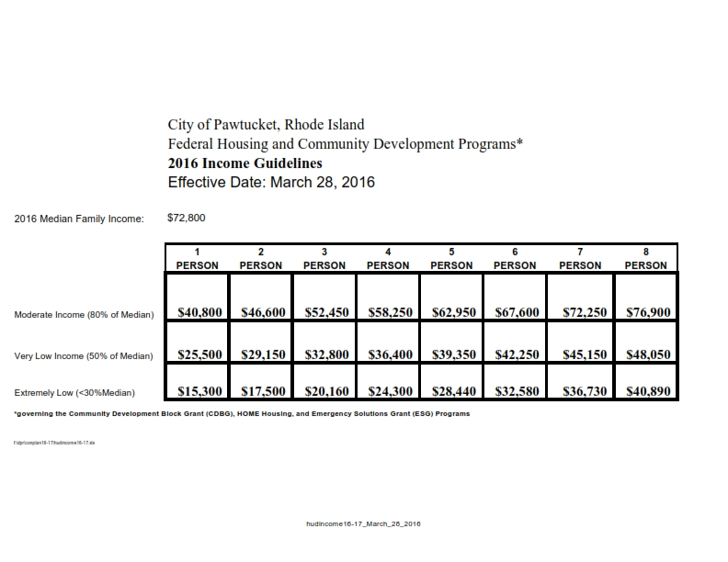
2016-2017 LOW AND MODERATE INCOME SCALE BY FAMILY SIZE

ATTACHMENT B
2017-2018 CONSOLIDATED PLAN ACTIVITY SCHEDULE
FOR
COMMUNITY DEVELOPMENT BLOCK GRANT
EMERGENCY SOLUTIONS GRANT
HOME HOUSING INVESTMENT PARTNERSHIPS

Monday, January 16, 2017 General Newspaper Notice/Email Meeting Invitation to non-profits, community groups and City Councilors

Tuesday, January 17, 2017 Prepare presentation, stats reviews from 2017-2018 grant year

Wednesday, January 18, 2017 Review HUD regulations for any changes in policy and procedures

Friday, January 20, 2017 Review 2015-2020 ConPlan Needs, restate needs

Tuesday, January 31, 2017 CDBG Public Meeting to Explain Grant Process
- Review Performance 2015-2016 (CAPER)
- Presentation of 1 yr. Con-Plan Needs/Explanation
CDBG/ESG/HOME Programs
Blackstone Valley Visitor Center Theatre,
175 Main Street, Pawtucket, RI - 6 p.m.

Wednesday, February 1, 2017 General Newspaper Notice/Applications Available/Applications emailed to City Council members

February 1-27, 2017 On-call meetings with applicants to assist with grant eligibility and preparation

Monday, February 27, 2017 Applications Due Date 4 P.M.

February 29 – March 4, 2017 Review of all submitted applications for eligibility/status of current CDBG grant if previously funded.

Wednesday, March 1, 2017 Email list of all applications received sent to Mayor and City Council in advance of public hearings

Tuesday, March 7, 2017 CDBG Public Service Application Public Hearing Blackstone Valley Visitor Center Theatre, 175 Main Street, Pawtucket, RI - 5 p.m. – 8 p.m.

Thursday, March 9, 2017 CDBG Activities/HOME Housing Applications Public Hearing Blackstone Valley Visitor Center Theatre, 175 Main Street, Pawtucket, RI - 5 p.m. – 7 p.m.

March 10 – March 23, 2017 Internal review of all submitted CDBG/HOME/ESG applications
against City’s Consolidated Plan Priorities

March 24 – April 10, 2017 Finalize funding application to HUD

Wednesday, April 5, 2017 Present application to City Council for Resolution authorizing Mayor to Submit Grant Application to HUD

Tuesday, April 11, 2017 HUD required newspaper advertisement announcing availability of final application for 30-day required public comment period.

April 11 – May 12, 2017 Input finalized funding plan into HUD prescribed format

Friday, May 12, 2017 Submit plan officially to HUD for 45-day review period

Monday, July 3, 2017 Anticipated approval date from HUD to begin FY18 Program Year funding.

ATTACHMENT C
City Organizations
Soares Edward
Tuesday, January 17, 2017 12:53 PM

Adrienne Marchetti; Amanda Carr; 'Amanda Carr'; Amy Gravell; Andrew Pierson; Silvia Andrew; Pires; Antonio; Antonio Moreira; Barbara Slover; Blackstone Valley Tourism; 'Bob Billington'; BV Emergency Food Center; Carlos Martins; Carolyn Kyle; Cheryl Larson Lawing; Christine Sullivan; 'Community MusicWorks'; Vitali; Albert; John Barry; Moran; Dave; Councilor John Barry III; Tetreault Lorenzo C; Wildenhain; Mark J.; Kallman; Meghan; Councilor Mercer; Councilor Moran; Councilor Rudd; Canol Sandra; Terrence Mercer; Rudd Jr. Timothy P.; Councilor Wildenhain; Cynthia Downie; Darius Shirzadi; Day One; Deborah Perry; Dylan Zelazo; Soares Edward; Gail Ahlers; Gilda Ferro; Holly Demers; James Jahnz; Jan Brodie; Rosa Jay; 'Jennifer Daugherty'; Jennifer Davis; 'Jim Hoyt'; Jim Matuszek; 'Jim Stewart'; Joao Goncalves; Blais John; Jorge Ferreira; Karen Feldman; Karen Jeffreys; Karyn Tillet; Kate Anderson; Kath Hunt; Krystal Durning; 'Linda Impagliazzo'; Linda Weisinger; Lisa Lacock; Lori Urso; Lorna Ricci; 'Mario Bueno'; Bourdeau! Mary; Moran! Mary Lou; 'Mary Parella'; Grebien, Donald; Melissa Smith; Michael Reis; Miriam Plitt; Natalie Carter; Oliver Dow; Patti McAlpine; Paul Fitzgerald; 'Peg Langhammer'; Reynaldo Almonte; Rhonda Price; Ricardo Pittswiley; Robert McCreanor, Esq.; Sean Cassidy; Sheri Griffin; Stefanie Lopes; Stephen Hug; 'Steve Vadnais'; Mara! Susan; Reed! Susan; Thomas Joyce; Vincent Ceglie

City of Pawtucket 2017-2018 CDBG and HOME Programs Consolidated Plan Needs Meeting Notice
Pawtucket Times Ad Jan.16 2017.pdf
1
Councilor John BarryIII
Moran, Dave
John Barry
Read:1/18/20174:50 PM
Delivered: 1/17/2017 12:53 PM
Vitali, Albert
'Community MusicWorks'
Christine Sullivan
Cheryl Larson Lawing
Carolyn Kyle
Carlos Martins
BV Emergency Food Center
'Bob Billington'
BlackstoneValley Tourism
BarbaraSlover
Antonio Moreira
Read:1/17/2017 3:52 PM
Pires,Antonio
Read:1/17/201712:57 PM
Silvia,Andrew
Andrew Pierson
Amy Gravell
'Amanda Carr'
Amanda Carr
Adrienne Marchetti
Tracking:
Read
Delivery
Recipient
Attachments:
Subject:
From:
Sent: To:
Edward
Soares,

2
Lori Urso
Lisa Lacock
Linda Weisinger
'Linda Impagliazzo'
Krystal Durning
Kath Hunt
Kate Anderson
Karyn Tillet
Karen Jeffreys
Karen Feldman
Jorge Ferreira
Read: 1/19/2017 11:24 AM
Blais, John
Joao Goncalves
'Jim Stewart'
Jim Matuszek
'Jim Hoyt'
Jennifer Davis
'Jennifer Daugherty'
Rosa, Jay
Jan Brodie
James Jahnz
Holly Demers
Gilda Ferro
Gail Ahlers
Read: 1/17/201712:53 PM
PM
1/17/201712:53
Delivered:
Soares, Edward
4:03 PM
Read: 1/17/2017
PM
1/17/201712:53
Delivered:
Dylan Zelazo
Deborah Perry
Day One
Darius Shirzadi
Cynthia Downie
Councilor Wildenhain
1/17/2017 12:53 PM
Delivered:
Rudd Jr. Timothy P.
Terrence Mercer
1/17/201712:53 PM
Delivered:
Cano, Sandra
Rudd
Councilor
Moran
Councilor
Mercer
Councilor
1/17/2017 12:53 PM
Delivered:
Kallman, Meghan
Wildenhain, Mark J.
4:36 AM
Read: 1/18/2017
Tetreault, Lorenzo C.
Recipient
Read
Delivery

CDBG/ESG/HOME Interested Parties

3
TO:
Delivered: 1/17/2017 12:53 PM
Councilor Lorenzo Tetreault
Delivered: 1/17/2017 12:53 PM
Councilor Mark J.Wildenhain
Delivered: 1/17/2017 12:53 PM
Councilor Terrence E.Mercer
Delivered: 1/17/2017 12:53 PM
Andrew Silvia
Delivered: 1/17/2017 12:53 PM
Anthony Pires
Delivered: 1/17/2017 12:53 PM
Mary Lou Moran
Delivered: 1/17/201712:53 PM
Mayor Donald Grebien
Delivered: 1/17/201712:53 PM
SusanMara
Delivered: 1/17/201712:53 PM
Jay Rosa
Delivered: 1/17/201712:53 PM
John Blais
Delivered: 1/17/201712:53 PM
Mary Bourdeau
Vincent Ceglie
Thomas Joyce
Reed,Susan
Read:1/17/20171:30 PM
Mara, Susan
'Steve Vadnais'
Stephen Hug
Stefanie Lopes
Sheri Griffin
SeanCassidy
Robert mcCreanor, Esq.
Ricardo Pittswiley
Rhonda Price
Reynaldo Almonte
'Peg Langhammer'
Paul Fitzgerald
Patti McAlpine
Oliver Dow
Natalie Carter
Miriam Plitt
Michael Reis
Melissa Smith
Grebien, Donald
'Mary Parella'
Read:1/17/2017 2:12 PM
Moran, Mary Lou
Bourdeau, Mary
'Mario Bueno'
Lorna Ricci
Recipient
Read
Delivery

2015-2016 Program Performance Review
2017 -2018 Consolidated Plan Needs Meeting
January 17, 2017
4
From Route 95 South:
Take Exit 28 (School Street Exit), at end of ramp stay to left. At stop sign, take left under the overpass. Go by
Apex on left to and through a set of lights and follow over Main Street Bridge, to a set of lights. At set of lights, take a right. We are directly on your left in the large brick building. The Visitors Center is on the first
floor. Parking is available in the first parking lot on the left - - 175 Main Street.
From Route 95 North:
Directions to Visitor Center 175 Main Street. Pawtucket. RI
*The Visitor Center is accessible to the disabled. Please see directions.
If you should have any questions or require specialized services to participate, please feel free to call
Edward G. Soares, Community Development Program Manager at 728-0500, ext. 441 or send an email
to esoares@pawtucketr.com
-Explanation of Federal Housing and Community Development
Consolidated Plan Programs
-Brief Review of 2015-2016 Program Performance
-Review of Needs/Program Priorities for 2017-2018 Period
-Public Input on Needs for 2017-2018 Program Year
-Explanation of Community Development Block Grant, Emergency Shelter, and HOME Program Applications.
Discussion Topics
2017-2018 Consolidated Plan Needs
2015-2016 Program Performance Review
Tuesday, January 31, 2017 at 6:00 p.m.
175 Main Street, 1st Floor
Valley Visitors Center Theatre'
Blackstone
funds.
one year consolidated plan, for the distribution of federal housing and community development
Pawtucket, Rhode Island would like to invite you to help the City develop our 2017-2018
The City of
SUBJECT:
DATE:
Edward G. Soares, CD Program Manager
Susan Mara, Acting Director
Jay Rosa, Senior Planner
FROM:

Edward G. Soares
Community Development
Program Manager
City of Pawtucket, Department of Planning and Redevelopment City Hall 1st Floor
137 Roosevelt Avenue
Pawtucket, RI 02860
401-728-0500 Ext. 441
401-497-2709 (Mobile)
www.pawtucketri.com
www.pawtucketartsfestival.org
- 175 Main Street.

5
to the building
adjacent
is available
Parking
right. The Visitors Center is on the first floor.
Take Exit 29 (Downtown Pawtucket). At stop sign, take a right. Go straight, go through first stop sign. At
second stop sign (next to Armory), take a right. Go to a set of lights (City Hall on Left) take a left onto
Roosevelt Avenue, pass City Hall on left. Our building is at the corner of Main Street and Roosevelt on the

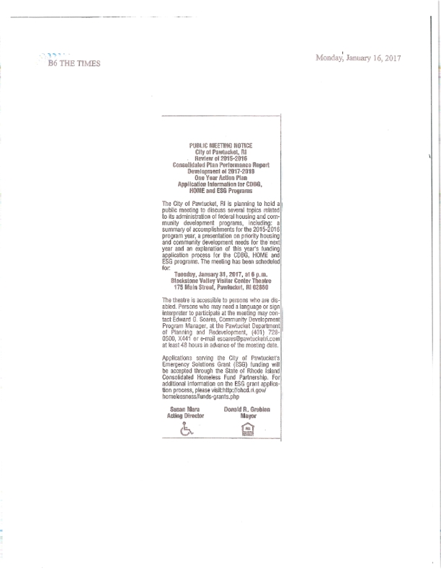

ATTACHMENT D

CITY OF PAWTUCKET

DISPLACEMENT AND RELOCATION POLICY

General Policy

As a general rule, the City of Pawtucket shall take all reasonable steps to minimize the displacement and relocation of persons (families, individuals, businesses, non-profit organizations, and farms) resulting from activities assisted with federal funds administered through the City of Pawtucket.
Where displacement and relocation are necessary, the City shall follow and comply with all of the applicable provisions found in 49 CFR part 24 (available upon request) which contains the government-wide regulations implementing the Uniform Relocation and Real Property Acquisition Policies Act of 1970, as amended.

