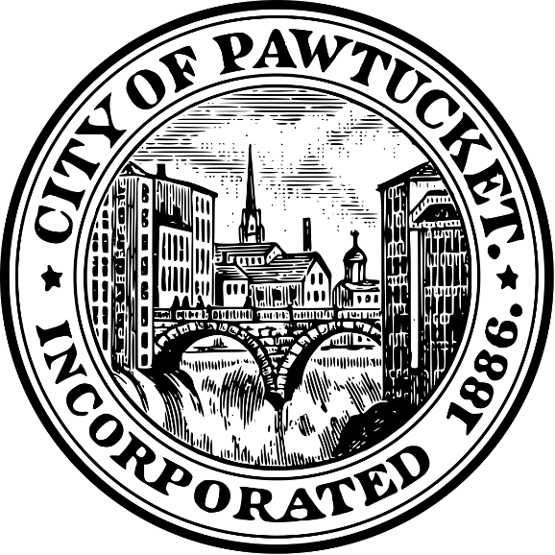

Request for Proposals

The Development of
Affordable Housing
Deed Restricted Affordable for a Period of 30 Years

160 Beechwood Avenue
Pawtucket, RI

Issue Date: December 13, 2021

Submission Due Date: January 5, 2022

CONTENTS:

Summary of the Offering……………………………………………………………....... I
Development Objectives…………………………………………………………………… II
Potential Public Partnership Considerations …………………………………........ III
Pre-Proposal Individual Development Team Meetings……………………....... IV
Proposal Submission Contents…………………………………………………………… V
Submission Instructions……………………………………………………………………. VI
Proposal Evaluation Criteria………………………………………………………......... VII
Award Process……………….…………………………………………………………........ VIII
Statement of Rights and Understanding…………………………………………….. IX
Questions……………………………………………………………………………………….. X

- Summary of the Offering:

The City of Pawtucket is seeking to enter into an agreement with a qualified housing developer to rehabilitate 160 Beechwood Avenue in Pawtucket, RI, 02860. The goal of this solicitation is to find a housing developer who has experience with similar housing development projects. This Request for Proposals (RFP) is the start of the process to select a housing developer to redevelop a 15,486 sq. ft. building owned and recently acquired from the State of Rhode Island. Proposals will be reviewed and evaluated by the City of Pawtucket, and they shall select a preferred developer for the project. The City will then negotiate an agreement for the redevelopment and rehabilitation of 160 Beechwood Avenue. The property consists of one (1) existing parcel. The parcel is located on Assessor’s Plat 35 Lot 360
The City may use American Rescue Plan Act (ARPA) funds and will be beholden to the objectives of that legislation during this procurement. All bidders are encouraged to review the ARPA Interim Final Rule regarding Affordable Housing objectives and incorporate them in your response.
The City encourages small and minority business participation throughout this RFP.

- Development Objectives:

The City is seeking proposals which will reuse this recently acquired 15,486 sq. ft. building currently vacant to provide an opportunity for HUD income qualified renters. The City would prefer that 60% of the units be at HOME Investments Partnership Program rent and income limits as published by HUD and 40% be market rate rentals. The property is currently zoned Residential Multi Family (RM). The City is desirous of responses which consider:

- Any of the uses that are allowed by right in the RM zone.

- A site and building design which respects the character of the
Neighborhood and its dwellings.

- A site and building design that is close to LEED certified and Lead safe.

A thorough description and recitation of all aspects of the proposed financing for the redevelopment of the property, including any proposed public/private financing vehicles to be explored.

- Potential Public Partnership Considerations:

The City is fully committed to being a partner in the redevelopment of this site and, toward that end, may explore with the chosen housing developer any of the following (and others that may be proposed) participatory tools:

- HOME Investment Partnerships Program

- Pre-Proposal Individual Development Team Meetings:

In order to facilitate an open exchange of information about the site and communicate the City’s vision for redevelopment, individual meetings can be scheduled with housing developers on the available date noted below. A site visit will be scheduled along with an office review to share all available information relative to the site. Any and all questions/requests for information raised at these individual meetings will be shared amongst all of developers following the conclusion of the individual developer meetings.

The following date is reserved for individual housing developer meetings:

Tuesday, December 21, 2021 12:00 p.m. – 4:00 p.m.

Please contact Mary Bourdeau at mbourdeau@pawtucketri.com to reserve a one hour time slot.

- Proposal Submission Contents:

The submission shall consist of the following elements, which should be provided in the order specified:

- Cover Letter
- Development Team Information
- Project Concept and Rehabilitation Plan
- Economic Benefits
- Affordable Housing Opportunity
- Project Timeline
- Project Financing

- Cover Letter
The cover letter shall serve as an Executive Summary of the overall proposal and must be signed by a principal authorized to represent and commit on behalf of the Housing Developer.

- Development Team Information
- Basic Information
- Identify the lead entity and principals.
- Indicate the form of legal entity (e.g., nonprofit corporation, corporation general partnership, etc.).

- Housing Developer
- Provide the names, titles, addresses, telephone numbers, e-mail addresses and resumes for key team members, including, but not limited to and to the extent known at this time: the developer, architect/designer, landscape architect, proposed general contractor (if known) and other consultant who would work with the developer on the project. Please provide an organizational chart that identifies key contacts and the relationship between team members.

- Relevant Experience
- Provide evidence of the Team’s past or current project experience, complete with project photographs or renderings.

- Project Concept and Development Plan
- In the narrative form, provide a general overview of the proposed plan for the development of the site.
- Offer rationale and evidence of market support for the development plan proposed for the site.
- Provide an overall conceptual site plan illustrating proposed site and building configurations, access and parking location, public access routes, general landscaping and other important site features.
- Specify any proposed municipal infrastructure improvements necessary to the project.
- Provide a conceptual elevation and/or perspective rendering of the proposed development, illustrating building materials and architectural character.

- Economic Benefits
- Provide a narrative outlining the project’s economic benefits to the City of Pawtucket.

- Affordable Housing Opportunity
- Provide a narrative of how this project will address public health or economic impacts of COVID-19 consistent with the goals of the American Rescue Plan Act.
- How the developer ensures that this project will benefit individual(s) disproportionately impacted by COVID-19.
- Project Timeline
- Provide a detailed project timeline chart which identifies the anticipated schedule for completing the development/rehabilitation of 160 Beechwood.

- Project Financing
- Specify the proposed purchase price.
- Include a description of the financial capacity of the Team in the form of annual reports, audited statements, balance sheets, evidence of lines of credit, and discretionary sources of equity.
- Specify the proposed project financing strategy, including all proposed sources and uses of funds
- Outline any of the proposed public participatory financing measures to be explored with the City should the Team be selected to negotiate an agreement.
- Provide a tentative commitment letter or letters from prospective lenders.

- Submission Instructions:

Responses should be mailed or delivered to:

City of Pawtucket
Department of Planning and Redevelopment
137 Roosevelt Avenue, 1st Floor
Pawtucket, RI 02860
SUBJECT: 160 Beechwood Avenue Affordable Housing Development Proposal

The submission should include the following:

- Two (2) bound hard copies and an electronic copy in a pdf format on a CD/Flash drive, including project financing.

Proposals are due on JANUARY 5, 2022. .

- Proposal Evaluation Criteria:

Proposals will be evaluated based on, but not limited to, the following criteria:

- Completeness of Proposal Response – The thoroughness of the proposal in addressing all of the requested submission information.

- Development Strategy Approach – The extent to which the proposed development is supported by sound economics and realistic financing.

- Economic Benefits – The proposal will be evaluated as to the thoroughness with which they address potential economic benefits to the City of Pawtucket.

- Physical Design – The proposal must respond to the site’s setting.

- Financial Plan and Capability – The proposal should demonstrate an effective and well-conceived financing plan and offer evidence of available financing to support the proposed development.

- Strength of Team – Each Team will be evaluated as to the track record and overall capability of the team leader, as well as each proposed partner.

- Award Process:

- Review of Proposals
The responses to this RFP will be reviewed and evaluated based upon the evaluation criteria previously outlined. The City will review each proposal. The City may request to hold interviews with selected teams.

City Selection
The City will make the decision with respect to the disposition of this property. As such, that body will select the Team with which to negotiate an Agreement.

- Negotiated Agreement
The final agreement to redevelop the site between the selected Team and the City will be in the form of an Agreement to be negotiated between the parties.

- Statement of Rights and Understanding:

- The City shall reserve the right to waive any irregularities in any submission.

- The City shall consider all information provided by Teams to be public record.

- The City shall reserve the right to undertake investigations with respect to the qualifications of each respondent and/or seek to obtain additional information deemed necessary to determine the ability of the respondent.

- The City reserves the right to reject any and all proposals.

- Questions:

Any questions relating to this RFP should be in e-mail form and addressed to Mary Bourdeau at mbourdeau@pawtucketri.com. Questions will be accepted until Tuesday 28th, 2021

Answers to all questions will be provided to all Teams by December 30, 2021.

